Click SQL WORKSHOP and after the drop down menu comes click SQL Scripts.

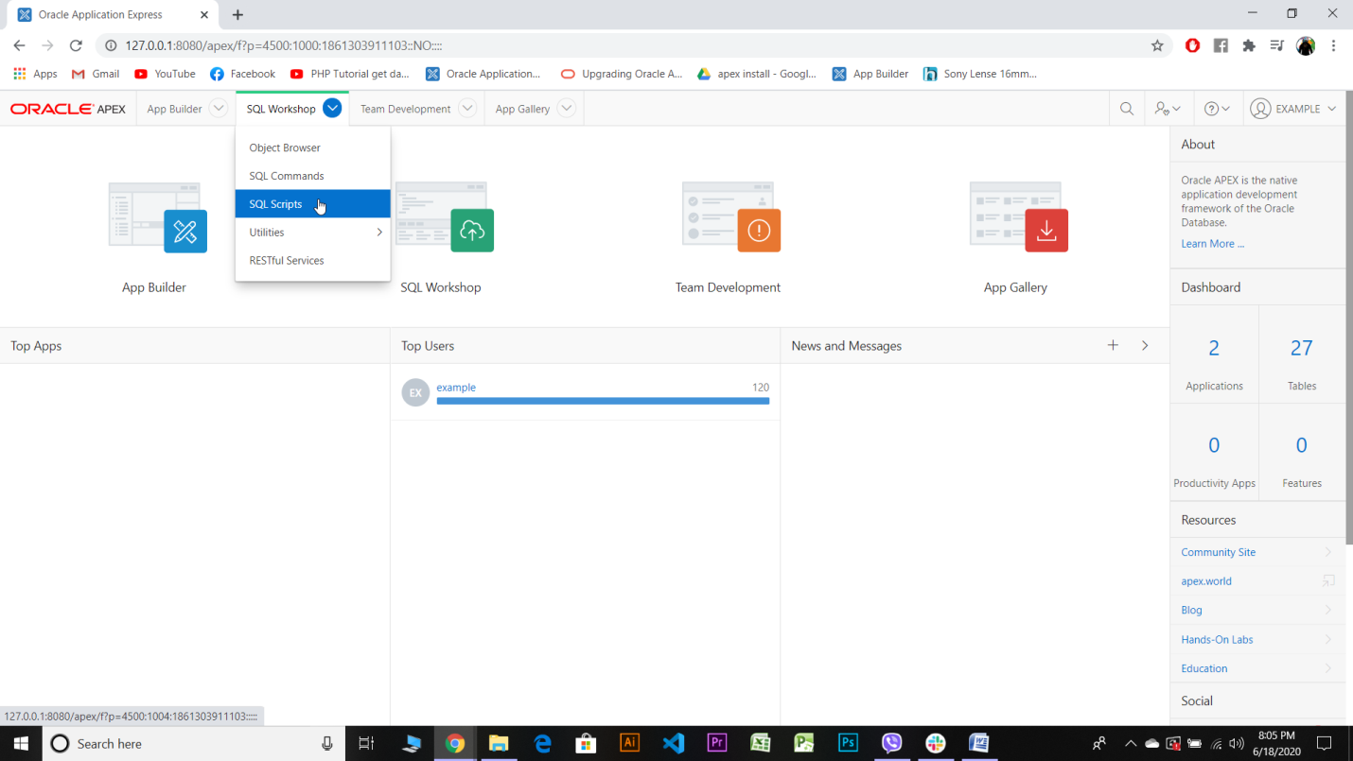

Go to upload

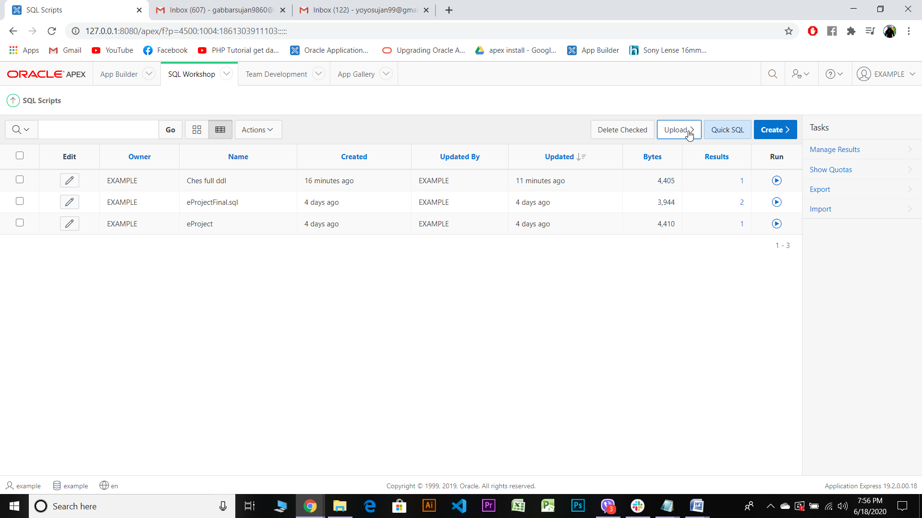

Then go to the respective directory and folder to choose the file to be uploaded.

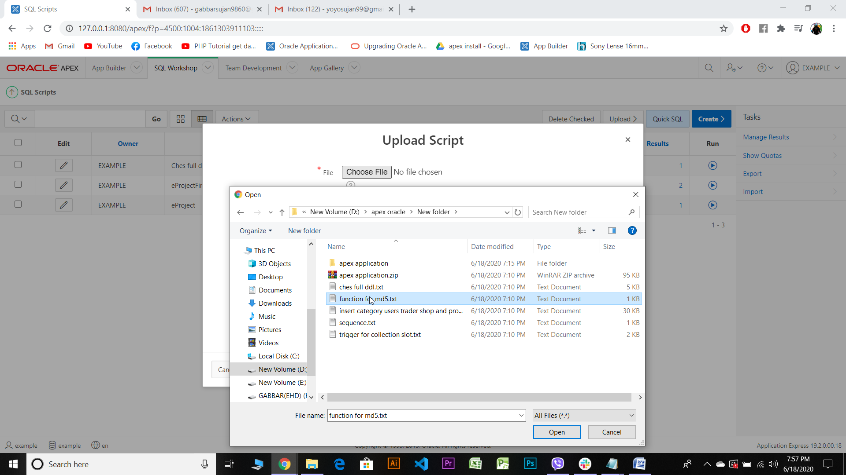

Give a name and click upload.

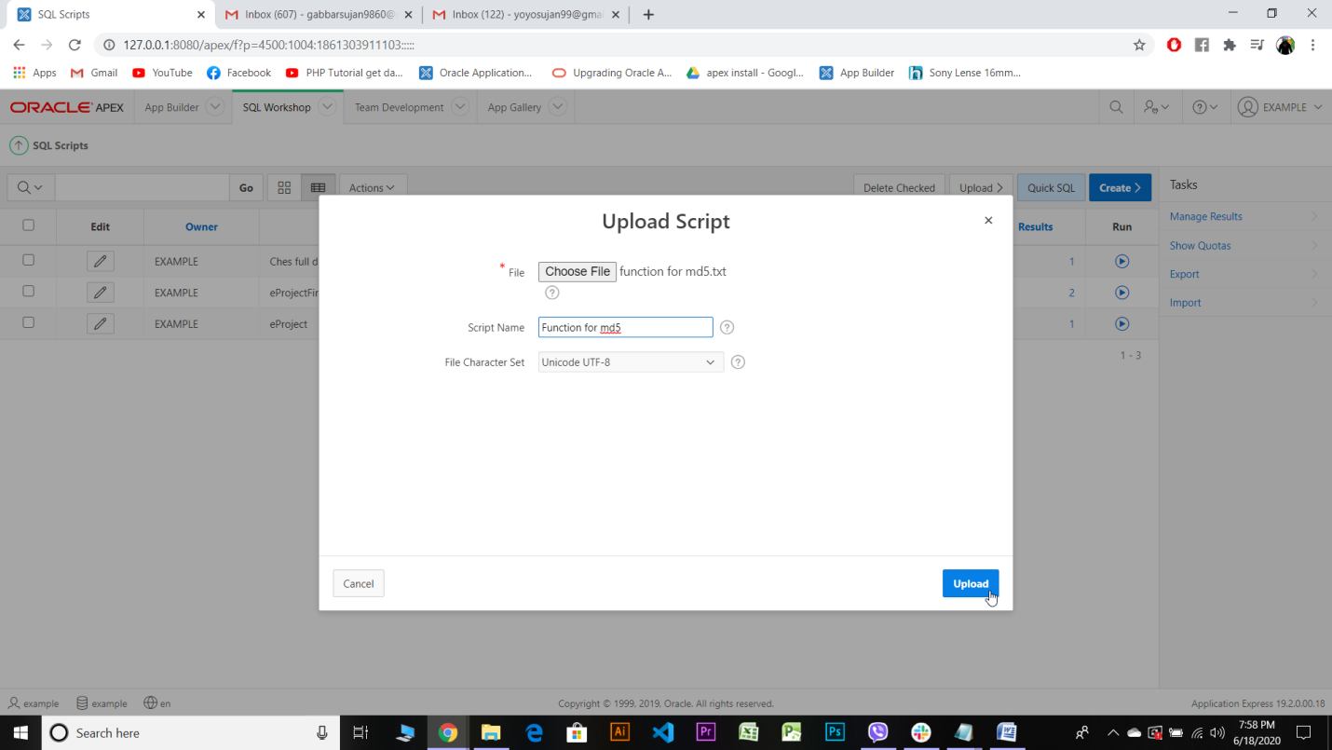

After that your uploaded file will appear on the screen.

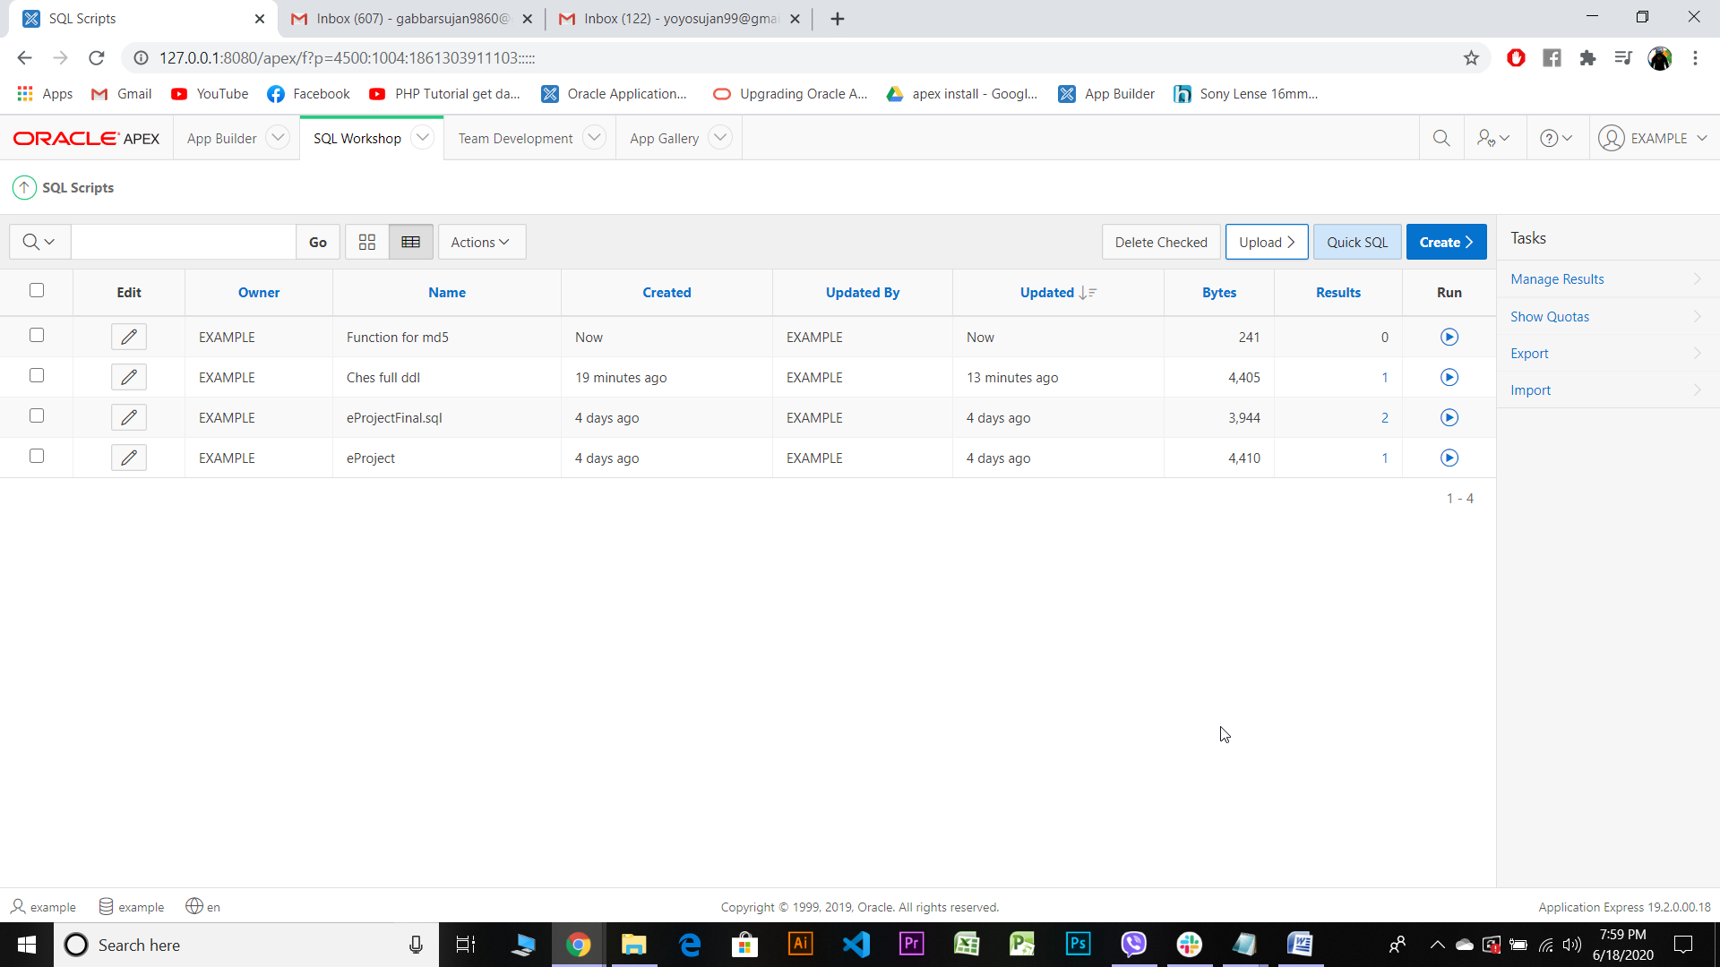

Then,Click run.

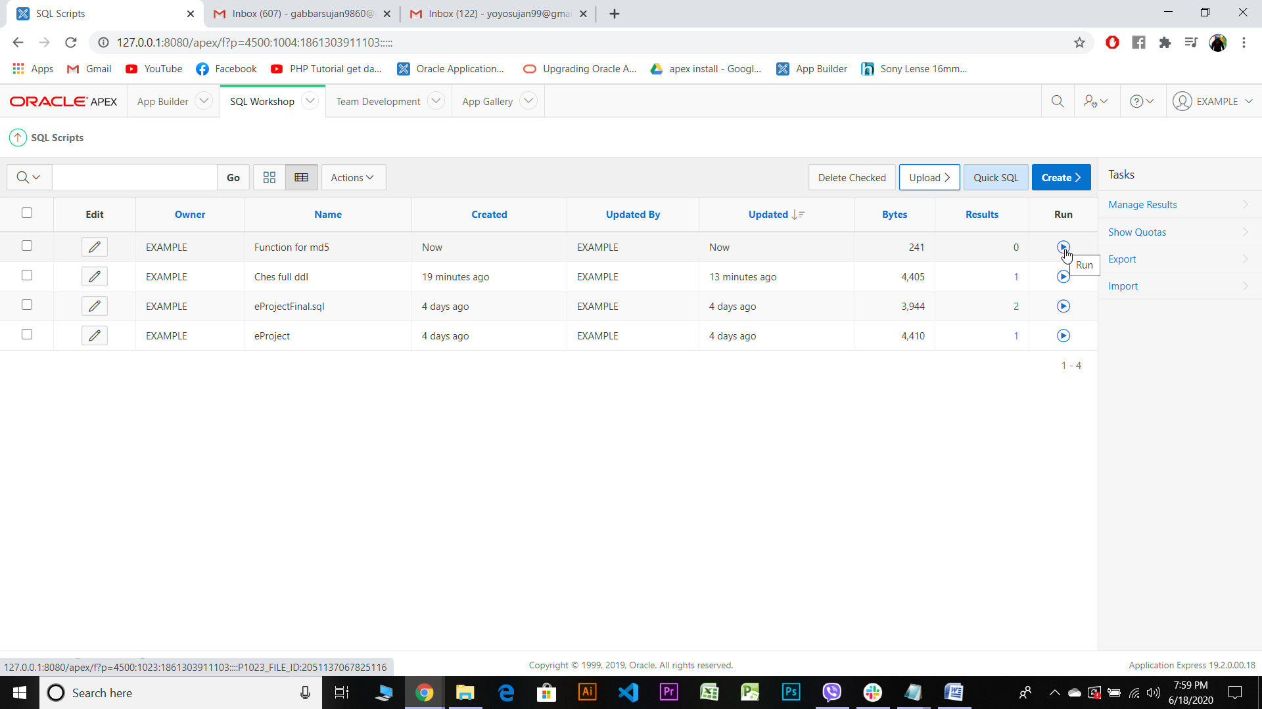

After clicking run, this will apper on your screen

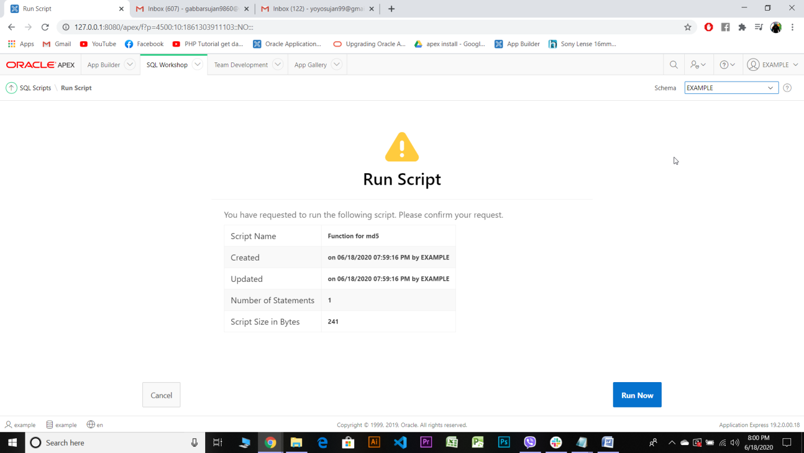

Then click Run Now.

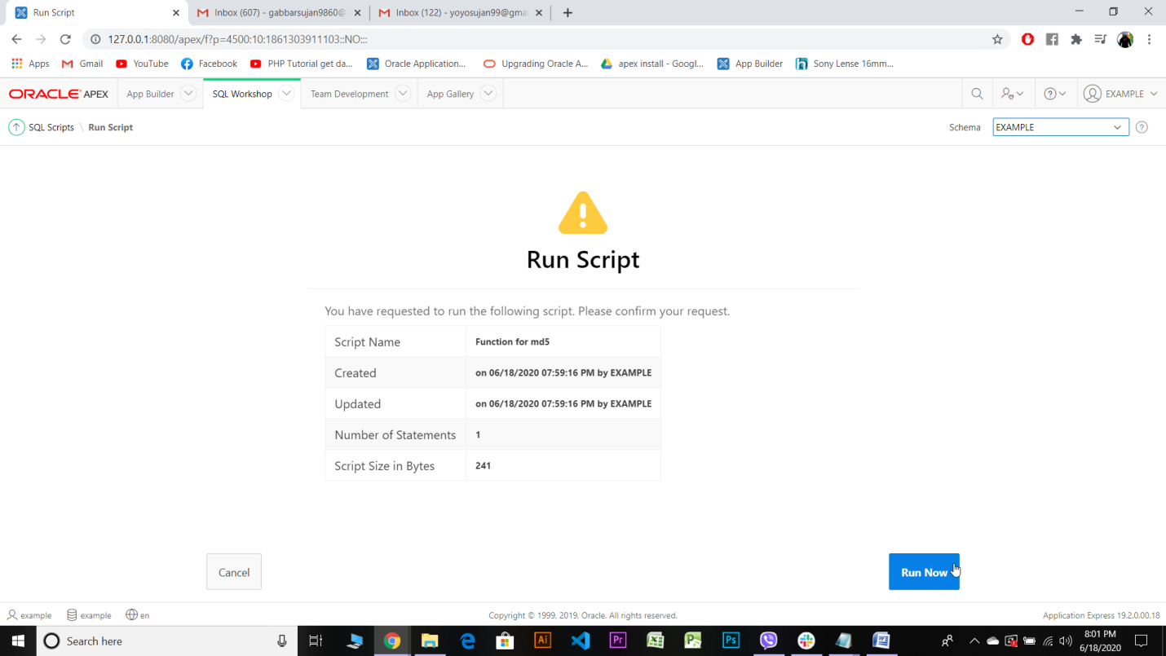

Then,Function will be created with 0 error.

